Hello and welcome to this Community Policing Team Report for
Potterne, Great Cheverell, Little Cheverell, Erlestoke, West Lavington, Market Lavington, Littleton Panell, Easterton, Urchfont, Worton and Marston
February 2019
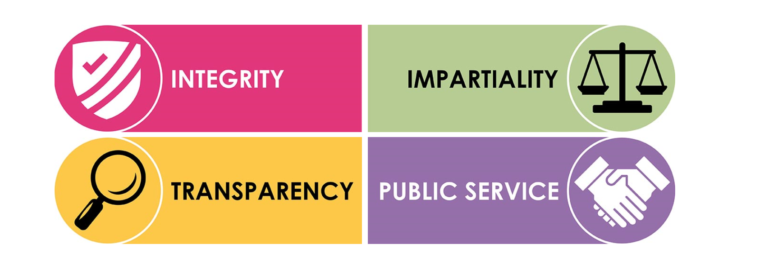
A reminder of your local Police Community Support Officer’s….

PCSO 8206 Paul WHITESIDE PCSO 8229 Georgie DODD
PEWSEY DEVIZES RURAL

PCSO 6093 Jon MILLS PCSO 6188 Melissa CAMILLERI
PEWSEY DEVIZES TOWN

PCSO 6035 Mark BRAITHWAITE PCSO 6169 Kelly WATTS
MARLBOROUGH DEVIZES TOWN

PCSO 6195 Lucy STONESTREET
MARLBOROUGH PCSO 6015 Paula YARRANTON
DEVIZES TOWN

PCSO 7712 Emily SYKES
MARLBOROUGH

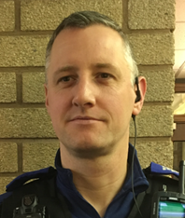
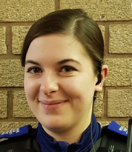

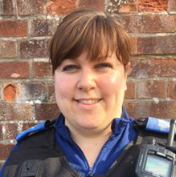

end it
PCSO 9454 Emily JOHNSON
PEWSEY

Advice for victims of fraud

If you suspect you've been a victim of fraud involving credit or debit cards, online banking or cheques, you should report it to your bank or card company.
They are responsible for undertaking further investigation and reporting criminal activity to us where appropriate.
Fraud that doesn't involve your bank or card company should be reported to the business or organisation concerned. Depending on their advice, you may then need to report this to us on 101.
Where an additional crime has been committed with the fraud, for example, you have had your wallet or purse stolen or the card used fraudulently was taken as a result of a burglary, then this should still be reported to us on 101.
Some steps you can take to protect yourself:
- Make sure you keep a record of all communications.
- Get a copy of your personal credit report from one of the credit reference agencies - Experian, Equifax and Call Credit. A paper version of your report is available from £2. If applications for credit have been made in your name you can ask to have any incorrect information removed.
- Consider contacting CIFAS - the UK's Fraud Prevention Service, to apply for protective registration. Once you have registered, CIFAS members will carry out extra checks whenever anyone applies for a financial service using your address.
- If you suspect mail theft, contact the Royal Mail Customer Enquiry Number on 08457 740740 or visit their website
If you are a victim of card fraud or online banking fraud you have protection through legislation, which states that you will not be liable for any losses unless you have acted fraudulently or without reasonable care.
Action Fraud can provide help and information online or by calling 0300 123 2040.

What to do - Disputes with neighbours
Landlord and tenant disputes
Landlord/ tenant relations are a very complex area of law and the following advice is only to be used as a guide. For more complete advice you should contact the Environmental Protection department of your local authority.
The proper procedure that a landlord must follow to legally evict a tenant is:
- A legal written notice
- A court order for possession and
- A bailiffs warrant (to be enforced by a County Court bailiff).
Until all these three steps have been taken, the tenant has a right to stay in the property.
Neighbour complaints and boundary disputes
Neighbour complaints can take many forms. Please contact us about the specific nature of the issue/complaint and we can advise further.
We do not have the power to deal with boundary disputes. This is a civil issue and you need to seek the advice of a solicitor to resolve any boundary issues you may have. It will be worthwhile contacting your bank or building society (or whoever holds your deeds) to check the boundaries.
House parties and illegal raves
If your neighbours are having a noisy house party, we have no powers of prosecution for noise offences. You need to contact the Environmental Health Department of your local authority.
If you believe that an illegal rave is taking place then contact us.
Some signs to look out for are:
- Groups of cars and young people gathering in unusual places such as industrial sites, small villages or remote rural areas
- Interest in certain remote, rural sites such as quarries, particularly by people that look out of place or you wouldn't expect to see
- Cars and vans delivering generators to rural locations.

Updates for your area…..

Local Crimes

Market Lavington:

On 01.02.19 an off duty police officer from Devizes Police detained a female for drink driving. On duty officers arrived on scene and arrested the female who was over three times over the limit.

Between 01.09.18 and 12.02.19 Unknown suspect/s have stolen a 6 metre folding roller and a feed manager stored in a field on a farm. Both items are of metal construction and are believed to have been cut up in situ. Due to the large time frame enquiries cannot be completed.

On 14.02.19 an unknown suspect has put a drill piece in the tyre of a vehicle. The victim has driven her vehicle and she has had to stop because of a flat tyre. It is believed this could be deliberate and actions have been taken to prevent this occurring again.

On 18.02.19 a male was stopped by officers on patrol for having no insurance. Whilst officers were conducting the traffic stop, the driver was found to have a controlled substance on him. The driver was tested positive for drugs and was arrested. The vehicle was seized.

On 20.02.19 officers were on patrol when the Automatic Number Plate Recognition showed a Wanted male in the area. The vehicle was stopped and the male was arrested.

Potterne:

On 02.02.19 a car has been damaged by unknown means. Unfortunately, as there are no forensic opportunities, CCTV or witnesses there are no other line of enquiries to be completed.

On 26.02.19 unknown suspect/s have tried to break into a vehicle unsuccessfully, the owner saw this and shouted at them and the males ran off. This appears to be a random incident and not targeted. Police regularly conduct patrols in the area.

Between 28.02.19 and 06.03.19, unknown suspect/s have stolen a secured trailer. The security device securing the trailer has also been stolen. Due to the large time frame and no CCTV, there are no lines of enquiry.

Erlestoke:

Overnight between 10.02.19 and 11.02.19 a package has been thrown over the prison. Due to no witnesses, CCTV or time line, enquiries have not continued.

On 26.02.19 we received a report of a suspicious vehicle, since then a package has been intercepted in the prison. Enquiries are ongoing.

Easterton:

On 10.02.19 an unknown suspect has thrown metal object at the victim’s kitchen window, causing damage to the outside pane. There have been no witnesses or CCTV, but Police have increased patrols in this area.

On 22.02.19, two unknown male suspects have attended the address, claiming to be surveyors there to look at her roof. The men were allowed entry into the house and spent some time making loud noises in the loft. It is unknown if any items were taken or if anything was damaged, but enquiries are ongoing.

Little Cheverell:

Overnight between 25.02.19 and 26.02.19 Unknown person/s have cut the padlock to a gate and taken a quad bike. Enquiries are ongoing.

Please dial 101 to report a crime and 999 in an emergency.

Please follow us on:

Twitter https://twitter.com/wiltshirepolice
Facebook https://www.facebook.com/wiltshirepolice/

Or sign up to Community Messaging https://www.wiltsmessaging.co.uk/

PCSO Georgina Dodd 8229
Team 3 Devizes
Wiltshire Police
07585987257

